PROJECT DESIGN PHASE-II
Technology Stack (Architecture & Stack)
Date | 30 September 2026
Team ID | SWTID-2026-6529
Project Name | LegalEase
Maximum Marks | 4 Marks
Team Leader | Sri Vijitha M
Team Members | Sree Harini P; Subalakshmi P; Sumaiya A

Technical Architecture
Project Architecture: LegalEase – AI-powered legal document generation and export application. Architecture focus: user interface, FastAPI application layer, AI integration, document generation services and configurable application settings.
Guidelines:
- Include all major processes as application logic / technology blocks.
- Provide infrastructural demarcation between local development and cloud-ready deployment.
- Indicate external interfaces such as the configured AI service.
- Indicate document-generation and output components.
- Indicate the interface to the AI/large language model.
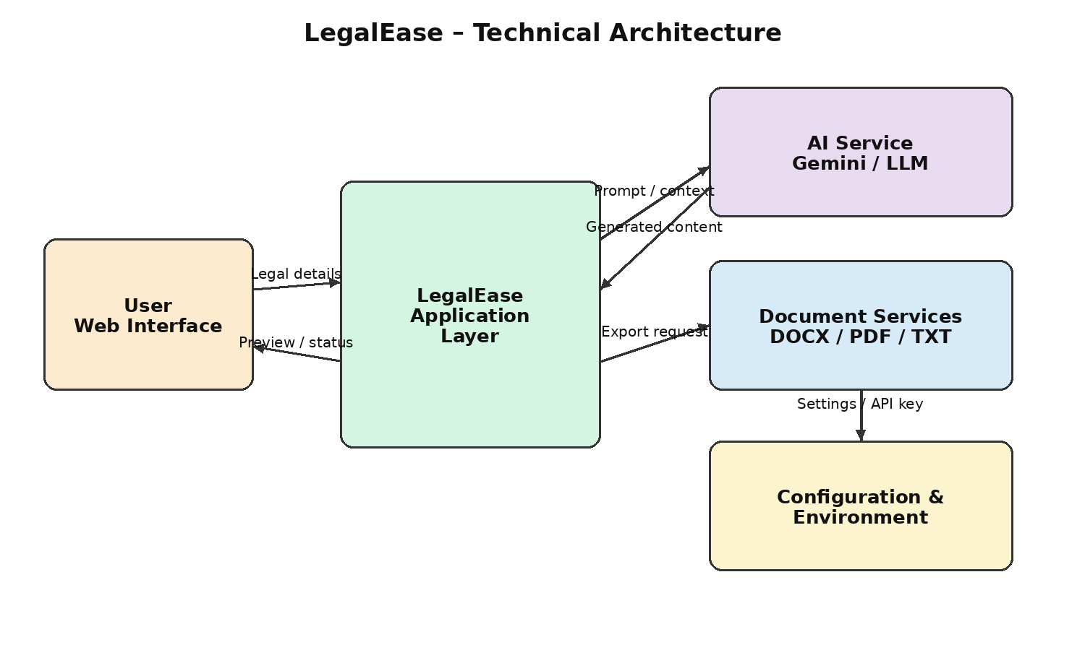

Project Architecture Flow
User → Streamlit Web Interface → FastAPI Application → Validation / Document Workflow → Gemini / LLM Service → Generated Legal Content → Preview / Editing → DOCX / PDF / TXT Export.

Table-1: Components & Technologies
S.No | Component | Description | Technology
1 | User Interface | Web interface for entering document type, parties, terms and effective date, previewing and editing generated documents. | Streamlit, HTML/CSS
2 | Application Logic-1 | REST API, request handling, validation, routing and application processing. | Python, FastAPI
3 | Application Logic-2 | Legal document generation workflow and coordination between user input, AI generation and export. | Python, FastAPI, Pydantic
4 | Application Logic-3 | AI-powered legal content generation using structured prompts and contextual user input. | Gemini API, prompt templates, Python
5 | Document Generation | Creation of formatted legal documents and export handling. | Python, python-docx, ReportLab
6 | Configuration | Application configuration and secure environment-based API settings. | Python, .env / environment variables
7 | External API | External AI service used for legal-document content generation. | Google Gemini API / LLM API
8 | Machine Learning Model | Generates structured legal-document content from supplied requirements and context. | Large Language Model (LLM)
9 | Output Files | Generated documents provided to the user in supported formats. | TXT, DOCX, PDF
10 | Infrastructure (Server / Cloud) | Local development and cloud-ready application deployment with a Python runtime. | Python runtime, Uvicorn, Docker / cloud hosting

Table-2: Application Characteristics
S.No | Characteristics | Description | Technology
1 | Open-Source Frameworks | Open-source Python web and document-generation libraries are used to support maintainability. | FastAPI, Streamlit, Pydantic, python-docx, ReportLab
2 | Security Implementations | Environment-based API credentials, input validation, sanitization and controlled error handling are used to reduce unsafe processing. | .env / environment variables, Pydantic validation, sanitization
3 | Scalable Architecture | Separation of UI, API/business logic, AI integration and document services allows components to be enhanced independently. | Layered architecture, REST API, modular Python services
4 | Availability | Uvicorn-based API deployment and health checking support reliable application operation and restart/recovery. | Uvicorn, FastAPI health endpoint, cloud hosting
5 | Performance | Structured requests, bounded input, efficient document generation and controlled AI calls reduce unnecessary processing. | FastAPI, Pydantic validation, modular document services

References
- FastAPI documentation
- Streamlit documentation
- Python documentation
- Google Gemini API documentation

Team Details
College | C.T.T.E College for Women
Team ID | SWTID-2026-6529
Team Leader | Sri Vijitha M
Team Member | Sree Harini P
Team Member | Subalakshmi P
Team Member | Sumaiya A

Architecture Flow & Implementation Note
Architecture Flow: User/Web UI → FastAPI Application Layer → Input Validation and Legal Document Workflow → External Gemini/LLM Service → Generated Legal Content → Preview/Edit → Document Services → TXT/DOCX/PDF outputs.
Implementation note: This LegalEase technology stack is based on the LegalEase project requirements already defined for AI-powered legal document generation, preview/editing and multi-format export. Where a specific deployment vendor is not fixed, the stack is described as cloud-ready rather than claiming a specific production provider.

